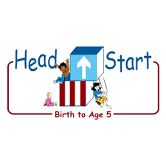PARENT ACTIVITY LETTER

CHILD’S NAME: ______________________

RATETHIS ACTIVITY FROM 1-5, CIRCLE YOUR RATING (5=HIGHEST RATING): 1 2 3 4 5
COMMENTS ABOUT THE ACTIVITY:
_______________________________________________________________________________________________________________________
**At this time while your child is learning at home, there’s no need to return this PAL to school, but you can keep it to go over with your child as a follow-up learning experience.
**Remember to have fun learning together!

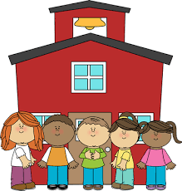

REMOTE lEARNING ACTIVITIES
The PAL Letters are developed to support your child’s academic/social-emotional progress and are related to the program’s School Readiness goals.
FOCUS BOOK
Recommended Read Aloud: Keep Counting By Ishan Zaidi
***Please remember to read aloud to your child daily. We recommend reading a minimum of 3 hours per week with your child.
Why It’s Important:
Exploring the different shapes, colors, and sizes provides a great opportunity for your child to learn about patterns.

Primary Objectives for the activity
This activity will encourage obj. 23 demonstrates knowledge of patterns

At home, invite your child to create a simple shape pattern to use as an example that you can share with them. Show your child different shapes that are available to them to use to make a pattern. Discuss the features of the different types of shapes. “This shape is blue, and it is also a heart. What do you notice about the shape you are holding?” Share your patterns with your child and read the pattern together. “I made a pattern with red and green. It is red, green, red, green, red, green, red, green.”

To extend this activity: Invite your child to create their own pattern by allowing them to pick out their own design. Make observations about what your child is creating. “I see red, yellow, and green shapes. When finished, ask them to tell you about the pattern created. Display the finished pattern.

