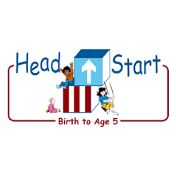**PARENT ACTIVITY LETTER**

**CHILD’S NAME: ______________________**

**RATETHIS ACTIVITY FROM 1-5, CIRCLE YOUR RATING (5=HIGHEST RATING): 1 2 3 4 5**

**COMMENTS ABOUT THE ACTIVITY:**

**_______________________________________________________________________________________________________________________**

**\*\*At this time while your child is learning at home, there’s no need to return this PAL to school, but you can keep it to go over with your child as a follow-up learning experience.**

**\*\*Remember to have fun learning together!**

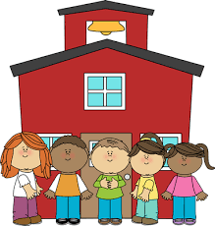

**REMOTE lEARNING ACTIVITIES**

*The PAL Letters are developed to support your child’s academic/social-emotional progress and are related to the program’s School Readiness goals.*

**FOCUS BOOK**

**Recommended Read Aloud**: The Pot That Juan Built by Nancy Andrews-Goebel.

***\*\*\*Please remember to read aloud to your child daily. We recommend reading a minimum of 3 hours per week with your child.*Primary Objectives for the activity**This activity will

**Why It’s Important:**

Engaging your child in conversations about their surroundings is a good way to develop vocabulary and make them more aware of their immediate environment. You give your child an opportunity to recall the details of your talk and make it easier to share the memory with others.

encourage 9a. Uses an expanding expressive vocabulary

**At home,** invite your child to join you on a “talking walk.” Explain that you will explore outside and see what you can find. “What do you think we will see on our walk around the playground?” As you walk together, talk about what you see. Point out insects under stones and squirrels in trees. Observe the weather, clouds, people, and passing cars. Encourage your child to use the paper bag to collect leaves, sticks, and other materials. Wonder aloud and ask questions that prompt them to describe what they find.

**To extend this activity:** Provide them with paper and glue to make a collage using the objects she collected. Offer to write down their description of the objects as they work on the collage. When finished, display the collage and description and encourage your child to share it with other family members or friends.