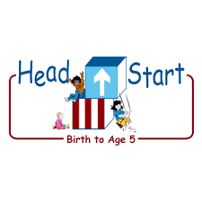**PARENT ACTIVITY LETTER**

**CHILD’S NAME: ______________________**

**RATETHIS ACTIVITY FROM 1-5, CIRCLE YOUR RATING (5=HIGHEST RATING): 1 2 3 4 5**

**COMMENTS ABOUT THE ACTIVITY:**

**_______________________________________________________________________________________________________________________**

**\*\*At this time while your child is learning at home, there’s no need to return this PAL to school, but you can keep it to go over with your child as a follow-up learning experience.**

**\*\*Remember to have fun learning together!**

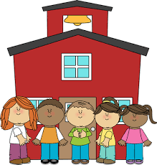

**REMOTE lEARNING ACTIVITIES**

*The PAL Letters are developed to support your child’s academic/social-emotional progress and are related to the program’s School Readiness goals.*

**FOCUS BOOK**

**Recommended Read Aloud**: A Chair For My Mother by Vera B. Williams

***\*\*\*Please remember to read aloud to your child daily. We recommend reading a minimum of 3 hours per week with your child.***

**Why It’s Important:**

Children love surprises! Guessing games provide a good opportunity to challenge your child’s thinking and help her learn to obtain information by asking questions.

**Primary Objectives forthe activity**

This activity will encourage 11d: Shows curiosity and motivation.

**At home**, choose objects that might be interesting to your child such as a seashell, new book, or toys you have at home. Make sure to select a range of objects, including some that are simple and others that will be more challenging for your child to guess as the activity is repeated. Choose one object to begin the game and put it in the pillowcase or bag without showing it to your child. Explain that they will ask questions to figure out what you have put in the bag. Encourage them to pose questions such as “Is it round? Is it kept inside or outside?” Also, comment on your child’s questions, and as the game continues, remind them of what information they already know. You have asked about the shape and color of the object. Now you know that it is round and red. When your child correctly identifies the object, take it out of the bag and talk about all of the attributes they determined with the questions that were asked.

**To extend this activity:** If you feel that your child has a good understanding of what types of questions to ask, you may wish to play again with a more challenging object.