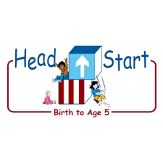PARENT ACTIVITY LETTER

CHILD’S NAME: ______________________

RATETHIS ACTIVITY FROM 1-5, CIRCLE YOUR RATING (5=HIGHEST RATING): 1 2 3 4 5
COMMENTS ABOUT THE ACTIVITY:
_______________________________________________________________________________________________________________________
**At this time while your child is learning at home, there’s no need to return this PAL to school, but you can keep it to go over with your child as a follow-up learning experience.
**Remember to have fun learning together!

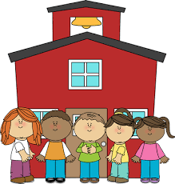

REMOTE lEARNING ACTIVITIES
The PAL Letters are developed to support your child’s academic/social-emotional progress and are related to the program’s School Readiness goals.
FOCUS BOOK
Recommended Read Aloud: House, Sweet House by Judith Bauer Stamper
***Please remember to read aloud to your child daily. We recommend reading a minimum of 3 hours per week with your child.
Why It’s Important:
Using active listening with your child lets them know that their feelings are being understood, even if they can’t verbalize them yet. When your child displays a strong emotion, active listening teaches them language that will help them eventually verbalize their feelings

Primary Objectives forthe activity
This activity will encourage 1a: Manages feelings.

At home, when your child shows strong emotions, get down to their eye level, make eye contact and offer a gentle touch to let them know that you are listening. If your child is not able to express themselves verbally, you may have to talk about what you see and assess their feelings about the situation. “You are frowning at Michael’s pile of blocks. Are you trying to tell him that you would like to have some of his blocks to play with?” If your child talks, repeat their words in language they can understand while reflecting their tone. “You want that truck! You really want that truck!” (Say this as you scrunch up your nose and furrow your brow.) Name and explain their feelings. “You are angry because Tommy has that truck.” Help your child put their feelings and needs into words, if possible.
To extend this activity: You and your child can create cards, drawing various facial expressions (happy, sad, mad…); show your child each card after and ask them what makes them feel that way and come up with ways to solve it.

