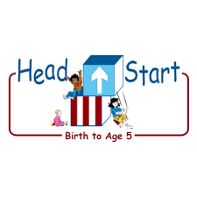PARENT ACTIVITY LETTER

CHILD’S NAME: ______________________

RATETHIS ACTIVITY FROM 1-5, CIRCLE YOUR RATING (5=HIGHEST RATING): 1 2 3 4 5
COMMENTS ABOUT THE ACTIVITY:
_______________________________________________________________________________________________________________________
**At this time while your child is learning at home, there’s no need to return this PAL to school, but you can keep it to go over with your child as a follow-up learning experience.
**Remember to have fun learning together!

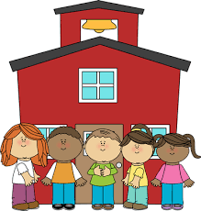

REMOTE lEARNING ACTIVITIES
The PAL Letters are developed to support your child’s academic/social-emotional progress and are related to the program’s School Readiness goals.
FOCUS BOOK
Recommended Read Aloud: M for Mittens by Annie Appleford
***Please remember to read aloud to your child daily. We recommend reading a minimum of 3 hours per week with your child.
Why It’s Important:
Learning to zip a zipper is a challenging task for your child to accomplish. It can be a frustrating experience when he/she is just learning how to hold on the bottom of his/her jacket. Always let your child perform the task independently before stepping in to help.
Primary Objectives for the activity
This activity will encourage 7a: Uses fingers and hands.

At home, provide a variety of outfits with buttons and zippers. Invite your child to explore the collection. Talk with him/her about getting dressed. “What would you like to wear this morning?” “What do you think is the easiest thing to put on?” Watch as your child puts their clothes on by himself/herself. Offer guidance if he/she asks for it without taking over and doing all for him/her. If your child has any difficulty, come up with a rhyme or jingle that might help him/her remember how to put on a shirt. For example, “Head goes in the big hole, arms go in the small holes.”

To extend this activity: give your child many opportunities to practice zipping and buttoning clothes. Your child may need to do it several times before he/she is successful. Remember to be consistent with your directions and patient while your child figures it out.

