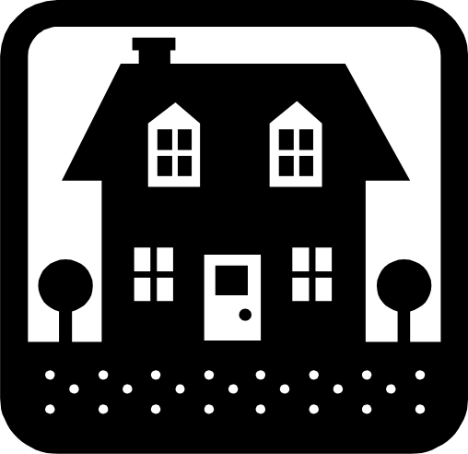

**Activity: “Shape Finder”**

**Developmental Focus Area: Math/Science**

**Age: Infant +**

**Shapes are all around us, and we use them in our everyday lives. Children use shapes as a method for sorting objects, as well as for building skills. What shapes can be stacked? What shapes can we roll? Learning shapes can improve communication, for example using descriptive phrases such as “round cookie” or “square window”. Go on a scavenger hunt indoors or out, and look for circles, triangles, squares, and rectangles. Talk with your child about the different shapes you see on your scavenger hunt.**

**Online Resource- Visit** [**www.pbskids.org**](http://www.pbskids.org) **for more activities and fun things to enjoy with your child while at home!**

***\*\*\*Please remember to read aloud to your child daily. We recommend reading a minimum of 3 hours a week with your child. ***

**The PAL letters are developed to support your child’s academic/social emotional progress and related to the programs School Readiness goals.**

**Child’s Name: ________________________________________**

**Parent Name: ________________________________________**

Rate this activity from 1-5, circle your rating (5= highest rating): **1 2 3 4 5**

Comments about the activity: (PROVIDE EXAMPLE) _____________________________________________________________________________________

I agree that completing the at home activity and reading aloud to my child is equivalent to four hours volunteer time for the week.

**Parent’s Signature:** ___________________________________________ **Date**: _______________

|  |  |  |  |
| --- | --- | --- | --- |
| **DATE** | **Activity Code** | **HOURS WORKED** | **RATE** |
|  | **HA** | **4 hours** |  |