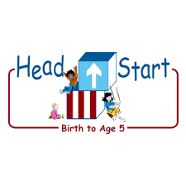**PARENT ACTIVITY LETTER**

**CHILD’S NAME: ______________________**

**RATETHIS ACTIVITY FROM 1-5, CIRCLE YOUR RATING (5=HIGHEST RATING): 1 2 3 4 5**

**COMMENTS ABOUT THE ACTIVITY:**

**_______________________________________________________________________________________________________________________**

**\*\*At this time while your child is learning at home, there’s no need to return this PAL to school, but you can keep it to go over with your child as a follow-up learning experience.**

**\*\*Remember to have fun learning together!**

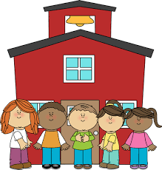

**REMOTE lEARNING ACTIVITIES**

*The PAL Letters are developed to support your child’s academic/social-emotional progress and are related to the program’s School Readiness goals.*

**FOCUS BOOK**

**Recommended Read Aloud**: Caps For Sale by Esphyr Slobodkina

***\*\*\*Please remember to read aloud to your child daily. We recommend reading a minimum of 3 hours per week with your child.***

**Why It’s Important:**

Grocery shopping, counting fruit, and mixing ingredients can teach your child a lot about math and reasoning skills. This activity will support your child’s growing ability to use numbers as he/she counts individual items needed for a salad.

**Primary Objectives for the activity**

This activity will encourage 20b: Quantifies.

**At home**, when you get back from your grocery shopping, invite your child to look at the fruit with you. Talk and ask him/her questions about the fruits you have. For example, “Which of these fruits do you like best? How do you want to eat your banana?”. Have your child pick out three kinds of fruits, for example: three apples, three bananas, three oranges or three from any seasonal fruit. Tell your child that you want to make a fruit salad and that you need his/her help. Have your child wash his/her hands and wash the fruits as well. As he /she is washing the fruit, encourage him/her to count each piece aloud. “How many fruits are washed? How many fruits are left to be washed? Remind your child how important it is to be careful when using a knife. Give him/her appropriately sized soft fruit chunks to cut with a plastic knife.

**To extend this activity**: Challenge your child to count out five pieces of each fruit after it is cut and place the pieces in separate bowls or cups. Ask “*Do the cups have the same amount of fruit? How many pieces of fruit are in the banana cup? or How many are in the apple cup?”* Invite your child to pour all the fruit cups into one bowl to make a fruit salad. As you share the salad, talk about the amounts of fruit you used.