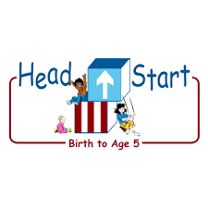PARENT ACTIVITY LETTER

CHILD’S NAME: ______________________

RATETHIS ACTIVITY FROM 1-5, CIRCLE YOUR RATING (5=HIGHEST RATING): 1 2 3 4 5
COMMENTS ABOUT THE ACTIVITY:
_______________________________________________________________________________________________________________________
**At this time while your child is learning at home, there’s no need to return this PAL to school, but you can keep it to go over with your child as a follow-up learning experience.
**Remember to have fun learning together!

REMOTE lEARNING ACTIVITIES
The PAL Letters are developed to support your child’s academic/social-emotional progress and are related to the program’s School Readiness goals.
FOCUS BOOK
Recommended Read Aloud: The Girl Who Wore Too Muchby Margaret Read MacDonald.
***Please remember to read aloud to your child daily. We recommend reading a minimum of 3 hours per week with your child.
Why It’s Important: Using art is an effective and fun, hands on way to extend your child’s learning about ideas and concepts that you have discussed with him/her.
Primary Objectives for the activity
This activity will encourage obj.14aThink symbolically

At home, think about ideas you have recently read or talked about that sparked your child’s interest. Gather magazines that contain pictures representing these concepts. For example, if you have talked about different insects, look for magazines that include pictures of a variety of insects. Some other ideas are vehicles, flowers, or birds. Invite your child to make a poster for the idea you have talked about. Explain that he/she may draw pictures to represent his/her idea or cut them out of magazines and glue them to the large paper. Write down some of your child’s words or encourage him/her to write his/her own words to the poster.
To extend this activity: When the poster is finished and the glue has dried, invite your child to help you hang it on the wall. Encourage him/her to share the poster with his/her friends and family members and explain his/her drawings or the pictures he/she chose to include.

