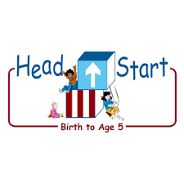PARENT ACTIVITY LETTER

CHILD’S NAME: ______________________

RATETHIS ACTIVITY FROM 1-5, CIRCLE YOUR RATING (5=HIGHEST RATING): 1 2 3 4 5
COMMENTS ABOUT THE ACTIVITY:
_______________________________________________________________________________________________________________________
**At this time while your child is learning at home, there’s no need to return this PAL to school, but you can keep it to go over with your child as a follow-up learning experience.
**Remember to have fun learning together!

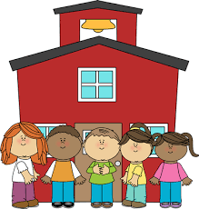

REMOTE lEARNING ACTIVITIES
The PAL Letters are developed to support your child’s academic/social-emotional progress and are related to the program’s School Readiness goals.
FOCUS BOOK
Recommended Read Aloud: Goldilocks and the Three Bears by Bonnie Dobkin
***Please remember to read aloud to your child daily. We recommend reading a minimum of 3 hours per week with your child.
Why It’s Important:
When children are very young, they obviously depend on adults to take care of any personal needs. Over time, children notice that others do these things for themselves. So, they become interested in gaining some of that independence.
Primary Objectives for the activity
This activity will encourage 1c: Take care of own needs appropriately.

At home, look for opportunities to express appreciation when your child takes responsibility for his/her personal needs. “You do such a good job washing your hands.” Read books with self –help themes, such as Jesse Bear, What Will You Wear? by Nancy Carlstrom or On Your Potty by Virginia Miller. Ask your child to model procedures for younger siblings or friends who might just be learning those skills. You can say “I can see that you put on your mittens to go outside. Can you show Janet how to put on her mittens?”.
To extend this activity: You can encourage your child’s development in other ways, such as by hanging photographs of him/her working on self-care tasks or inviting him/her to make a story using the pictures.

