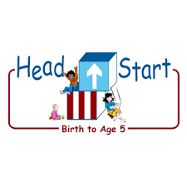**PARENT ACTIVITY LETTER**

**CHILD’S NAME: ______________________**

**RATETHIS ACTIVITY FROM 1-5, CIRCLE YOUR RATING (5=HIGHEST RATING): 1 2 3 4 5**

**COMMENTS ABOUT THE ACTIVITY:**

**_______________________________________________________________________________________________________________________**

**\*\*At this time while your child is learning at home, there’s no need to return this PAL to school, but you can keep it to go over with your child as a follow-up learning experience.**

**\*\*Remember to have fun learning together!**

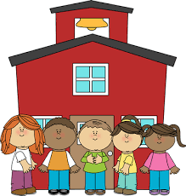

**REMOTE lEARNING ACTIVITIES**

*The PAL Letters are developed to support your child’s academic/social-emotional progress and are related to the program’s School Readiness goals.*

**FOCUS BOOK**

**Recommended Read Aloud**: Play Ball! By Nancy Noel Williams

***\*\*\*Please remember to read aloud to your child daily. We recommend reading a minimum of 3 hours per week with your child.***

**Why It’s Important:**

A larger ball presents a new challenge for your child as they learn to coordinate their arms and legs together. Learning to grasp, throw, and catch and object will help them refine his gross-motor abilities and apply those skills to ordinary movements and activities.

**Primary Objectives for the activity**

6. Demonstrates gross-motor manipulative skills

**At home, invite your child to:** explore a ball outside. It can be any type of ball, but a larger one will work the best (beach ball, soccer ball). Allow them to play freely with the ball before demonstrating additional ways the ball can be used, such as kicking, pushing, and bouncing. Offer to use the ball with your child in various ways. “You rolled the ball to me. Now I’ll roll it back to you. Can you roll it to me again?” Offer encouragement when they attempt a new technique with the ball. “You did a great job throwing that ball!”

**To extend this activity:** make a ramp using something in the house (a box, a poster board, ect). Let your child explore the ramp with the ball. Offer them support if needed. “What do you think will happen if we put the ball at the top? Will the ball stop at the bottom?” Continue using the ball for as long as your child is interested.