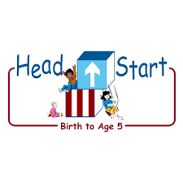PARENT ACTIVITY LETTER

CHILD’S NAME: ______________________

RATETHIS ACTIVITY FROM 1-5, CIRCLE YOUR RATING (5=HIGHEST RATING): 1 2 3 4 5
COMMENTS ABOUT THE ACTIVITY:
_______________________________________________________________________________________________________________________
**At this time while your child is learning at home, there’s no need to return this PAL to school, but you can keep it to go over with your child as a follow-up learning experience.
**Remember to have fun learning together!

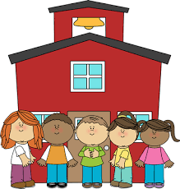

REMOTE lEARNING ACTIVITIES
The PAL Letters are developed to support your child’s academic/social-emotional progress and are related to the program’s School Readiness goals.
FOCUS BOOK
Recommended Read Aloud: Have a Ball by Nancy Noel Williams
***Please remember to read aloud to your child daily. We recommend reading a minimum of 3 hours per week with your child.
Why It’s Important:
Children who can look at a book and identify objects on the page comprehend what they see. If your child can answer questions about content, they understand what they hear. Asking questions about a book while you read together can help your child interpret pictures and words on the pages.
Primary Objectives for the activity
18a. Interacts during reading experiences, book conversations, and text reflections

At home, invite your child to: read with you. Each time you read with your child, make the reading interactive. Ask questions about each page of the book. “What colors do you see on this ball? Do you think this ball will bounce?” Encourage your child to ask a question if they are unsure about something in the book. Ask a variety of questions that they can answer verbally or nonverbally. “Where are these people playing with the ball? Can you tell me what you think they will do next? How do balls roll?” Start with simple questions and then move on to more complex questions if your child is ready.
To extend this activity: Read the same book to your child each day for a few days straight. Ask the same questions each time. This is a great way to build your child’s confidence and comfort with books.

