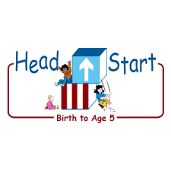**PARENT ACTIVITY LETTER**

**CHILD’S NAME: ______________________**

**RATETHIS ACTIVITY FROM 1-5, CIRCLE YOUR RATING (5=HIGHEST RATING): 1 2 3 4 5**

**COMMENTS ABOUT THE ACTIVITY:**

**_______________________________________________________________________________________________________________________**

**\*\*At this time while your child is learning at home, there’s no need to return this PAL to school, but you can keep it to go over with your child as a follow-up learning experience.**

**\*\*Remember to have fun learning together!**

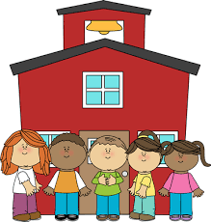

**REMOTE lEARNING ACTIVITIES**

*The PAL Letters are developed to support your child’s academic/social-emotional progress and are related to the program’s School Readiness goals.*

**FOCUS BOOK**

**Recommended Read Aloud**: A Birthday Basket for Tia by Pat Mora

***\*\*\*Please remember to read aloud to your child daily. We recommend reading a minimum of 3 hours per week with your child.***

**Why It’s Important:**

Preschool children are focused on the present. They begin to learn about time in relation to themselves. By talking with your child about what they did this morning or what they will do this afternoon, they begin to have an awareness of time and sequence.

**Primary Objectives for the activity**

12a. Recognizes and recalls 22b.Measures time and money

**At home, invite your child to:** talk about their day. Ask questions that prompt them to think about the various parts of the day. For example, “What did you do before you ate breakfast this morning? What will you do after dinner tonight?” Allow your child time to think and remember as they talk about their day.

**To extend this activity:** have your child create a picture showing what they did that day from morning to night. Ask, “What did you do first? What happened next? What will you do later?” When they finish the picture, hang it up so they can share it with others.