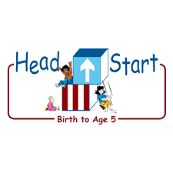**PARENT ACTIVITY LETTER**

**CHILD’S NAME: ______________________**

**RATETHIS ACTIVITY FROM 1-5, CIRCLE YOUR RATING (5=HIGHEST RATING): 1 2 3 4 5**

**COMMENTS ABOUT THE ACTIVITY:**

**_______________________________________________________________________________________________________________________**

**\*\*At this time while your child is learning at home, there’s no need to return this PAL to school, but you can keep it to go over with your child as a follow-up learning experience.**

**\*\*Remember to have fun learning together!**



**REMOTE lEARNING ACTIVITIES**

*The PAL Letters are developed to support your child’s academic/social-emotional progress and are related to the program’s School Readiness goals.*

**FOCUS BOOK**

**Recommended Read Aloud**: Something from Nothing by Phoebe Gilman

***\*\*\*Please remember to read aloud to your child daily. We recommend reading a minimum of 3 hours per week with your child.***

**Why It’s Important:**

This activity will support your child’s growing ability to compare the quantities of small groups of objects and correctly use comparison words, such as more and less. Becoming more aware of “number” words will help your child begin to use comparison words in daily conversation.

**Primary Objectives for the activity**

This activity will encourage 20b

Quantifies

**At home, invite your child to:** Before you begin, place six cotton balls in a small jar. Fill another jar with ten cotton balls. Place the jars on two separate pieces of paper. Invite your child to explore the jars and guess which jar holds more cotton balls. Write the words more and less on the jars your child designates. Explain that your child can check his/her prediction. Encourage your child to empty one of the jars and glue the balls on the paper. Repeat with the other jar. Provide assistance, if needed, as your child counts and glues the cotton balls. Once your child has counted both sets of cotton balls, ask your child which paper has more and which has less.

**To extend this activity:** You can vary the game by using collections of other small objects that you can find around your house.