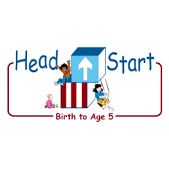**PARENT ACTIVITY LETTER**

**CHILD’S NAME: ______________________**

**RATETHIS ACTIVITY FROM 1-5, CIRCLE YOUR RATING (5=HIGHEST RATING): 1 2 3 4 5**

**COMMENTS ABOUT THE ACTIVITY:**

**_______________________________________________________________________________________________________________________**

**\*\*At this time while your child is learning at home, there’s no need to return this PAL to school, but you can keep it to go over with your child as a follow-up learning experience.**

**\*\*Remember to have fun learning together!**

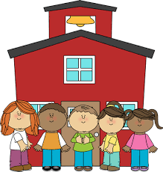

**REMOTE lEARNING ACTIVITIES**

*The PAL Letters are developed to support your child’s academic/social-emotional progress and are related to the program’s School Readiness goals.*

**FOCUS BOOK**

**Recommended Read Aloud**: Sam Helps Recycle by Judith Bauer Stamper

***\*\*\*Please remember to read aloud to your child daily. We recommend reading a minimum of 3 hours per week with your child.***

**Why It’s Important:**

Provide your child with lots of interesting objects to explore and discover encourage your child to use language to describe what your child is doing, seeing, and feeling

**Primary Objectives for the activity**

This activity will encourage 9a.

Uses an expanding expressive vocabulary

**At home, invite your child to:** find many objects around your house and put them in a big basket and prepare two medium-sized bins labeled *Recycle and Non- Recycle.* Invite your child to join you in exploring the collection of items. Show your child the collection and allow your child to examine each item. Ask your child if he/she can help you sort the items. Invite your child to choose an item out of the basket. Ask your child if it goes in the recycle or non-recycle bin. Encourage your child to use new vocabulary to talk about the item. When your child makes a decision, have your child place the item in the bin with the appropriate label.

**To extend this activity:** You can extend this activity by adding more bins (plastic, paper, can) and inviting your child to designate his/her own categories for sorting