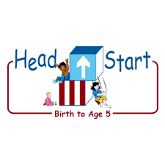PARENT ACTIVITY LETTER

CHILD’S NAME: ______________________

RATETHIS ACTIVITY FROM 1-5, CIRCLE YOUR RATING (5=HIGHEST RATING): 1 2 3 4 5
COMMENTS ABOUT THE ACTIVITY:
_______________________________________________________________________________________________________________________
**At this time while your child is learning at home, there’s no need to return this PAL to school, but you can keep it to go over with your child as a follow-up learning experience.
**Remember to have fun learning together!

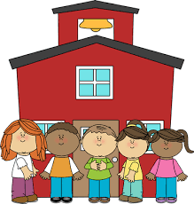

REMOTE lEARNING ACTIVITIES
The PAL Letters are developed to support your child’s academic/social-emotional progress and are related to the program’s School Readiness goals.
FOCUS BOOK
Recommended Read Aloud: The True Story of the 3 Little Pigs! By; Jon Scieszka
***Please remember to read aloud to your child daily. We recommend reading a minimum of 3 hours per week with your child.
Why It’s Important:
This activity will help your child name and identify shapes. Math is a wonderful way for your child to exercise their knowledge of shapes. This is a great way for your child to organize visual information and build math skills.
Primary Objectives for the activity
This activity will encourage 21b understands shapes.

At home, invite your child to: Play "I'm Thinking of a Shape" by asking the children to identify the shape you describe. You can display a few shapes and let the children choose what they think is the right one or hide the shape you are describing. Continue the game using the collection of everyday objects.
To extend this activity: Invite your child to examine the geometric solids. Introduce them to the shape names and discuss their attributes. For example, a rectangular prism and cube are "like a box," a cylinder is "like a can," and a sphere is "like a ball."

