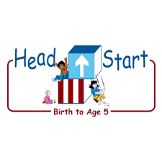PARENT ACTIVITY LETTER

CHILD’S NAME: ______________________

RATETHIS ACTIVITY FROM 1-5, CIRCLE YOUR RATING (5=HIGHEST RATING): 1 2 3 4 5
COMMENTS ABOUT THE ACTIVITY:
_______________________________________________________________________________________________________________________
**At this time while your child is learning at home, there’s no need to return this PAL to school, but you can keep it to go over with your child as a follow-up learning experience.
**Remember to have fun learning together!

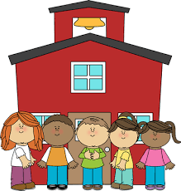

REMOTE lEARNING ACTIVITIES
The PAL Letters are developed to support your child’s academic/social-emotional progress and are related to the program’s School Readiness goals.
FOCUS BOOK
Recommended Read Aloud: The Three Little Pigs By: Bonnie Dobkin
***Please remember to read aloud to your child daily. We recommend reading a minimum of 3 hours per week with your child.
Why It’s Important:
Poems are a great way to enhance your child’s literacy skills with word recognition. Literacy is the key to interpreting information and allowing your child to feel confident and independent when communicating.
Primary Objectives for the activity
This activity demonstrates phonological awareness, skills, and word recognition 15b.

At home, invite your child to: perform the actions with you as you recite the following poem: Tubes and tunnels turn and twist [twist back and forth], Tubes and tunnels are round like this [make arms into a big circle]. Trains and trucks can drive right through [turn steering wheel], Tunnels as they blow “woo-woo” [blow horn]. Tubes carry water to the tap, Turn it on just like that [turn wrist]., Tubes and tunnels are here, there, and everywhere! [point all around]

To extend this activity: Read the poem slowly, without actions and ask your child to clap each time they hear a word that begins with the /t/ sound

