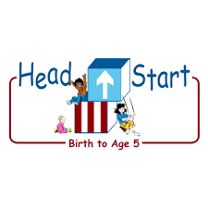PARENT ACTIVITY LETTER

CHILD’S NAME: ______________________

RATETHIS ACTIVITY FROM 1-5, CIRCLE YOUR RATING (5=HIGHEST RATING): 1 2 3 4 5
COMMENTS ABOUT THE ACTIVITY:
_______________________________________________________________________________________________________________________
**At this time while your child is learning at home, there’s no need to return this PAL to school, but you can keep it to go over with your child as a follow-up learning experience.
**Remember to have fun learning together!

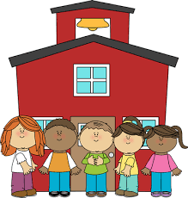

REMOTE lEARNING ACTIVITIES
The PAL Letters are developed to support your child’s academic/social-emotional progress and are related to the program’s School Readiness goals.
FOCUS BOOK
Recommended Read Aloud: Buildings, Buildings, Buildings By: Judith Bauer Stamper
***Please remember to read aloud to your child daily. We recommend reading a minimum of 3 hours per week with your child.
Primary Objectives for the activity
Why It’s Important:
Children who provide effort in their activities, lead to achievement. Given the link between persistence and academic success, decisions about effort are important in child development.
This activity will encourage your child to persist through tasks, Objective 11b.

At home: Put a set of blocks in a box or dishpan. Set out the box for your child to explore. Watch how your child plays with the blocks, encourage them to see how high they can stack them. (If you don’t have blocks you can use books/boxes) When the tower falls, encourage them to stack it again.

To extend this activity: Have your child count the highest stack they made to see how high they can go without help.

