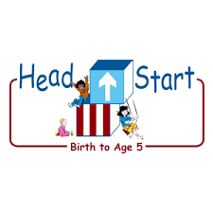PARENT ACTIVITY LETTER

CHILD’S NAME: ______________________

RATE THIS ACTIVITY FROM 1-5, CIRCLE YOUR RATING (5=HIGHEST RATING): 1 2 3 4 5
COMMENTS ABOUT THE ACTIVITY:
_______________________________________________________________________________________________________________________
**At this time while your child is learning at home, there’s no need to return this PAL to school, but you can keep it to go over with your child as a follow-up learning experience.
**Remember to have fun learning together!

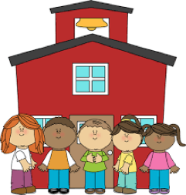

REMOTE lEARNING ACTIVITIES
The PAL Letters are developed to support your child’s academic/social-emotional progress and are related to the program’s School Readiness goals.
FOCUS BOOK
Recommended Read Aloud: Building A House By: Byron Barton
***Please remember to read aloud to your child daily. We recommend reading a minimum of 3 hours per week with your child.
Why It’s Important:
Performing simple household routines throughout the day allows your child to take responsibility for their environment. Many times, children are able to complete simple routines such as clearing their spot at the table, cleaning up toys, or washing their hands when they come in from outside with a few reminders.

However, there are times when children will need more support to complete a routine. Making routines silly and interactive is a positive way to encourage children to participate in each task.
Primary Objectives for the activity
This activity will regulate emotions and behaviors by following limits and expectations: Obj 1b

At home, invite your child to: look for opportunities to help with household jobs. Create many small jobs, such as “feeding fish, watering plants, throwing out trash” Discuss something they can relate to, like how ants work together to build their homes and collect their food. Ask, “Do you think we can clean up our house like ants? How can we do that? Can you show me how?" By asking these questions, you are pointing out how working together and limits benefits the WHOLE family. We all clean up our toys and put away our clothes, because we don't want to lose our things. We all clean up together, so we can finish quicker and then we can play.
To extend this activity: Come up with a cleanup song that you can share with your child when it is time. Here is an example (tune of “BINGO”:
Ants help each other as they work,
They always work together.
Let’s clean up like ants,
Let’s clean up like ants,
We can work together!

