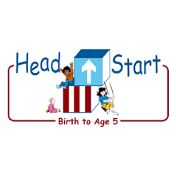PARENT ACTIVITY LETTER

CHILD’S NAME: ______________________

RATETHIS ACTIVITY FROM 1-5, CIRCLE YOUR RATING (5=HIGHEST RATING): 1 2 3 4 5
COMMENTS ABOUT THE ACTIVITY:
_______________________________________________________________________________________________________________________
**At this time while your child is learning at home, there’s no need to return this PAL to school, but you can keep it to go over with your child as a follow-up learning experience.
**Remember to have fun learning together!

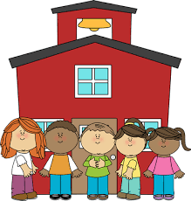
5/7/2020

REMOTE lEARNING ACTIVITIES
The PAL Letters are developed to support your child’s academic/social-emotional progress and are related to the program’s School Readiness goals.
FOCUS BOOK
Recommended Read Aloud: Trees Count by Trish Holland
***Please remember to read aloud to your child daily. We recommend reading a minimum of 3 hours per week with your child.
Why It’s Important:
Finding new ways to encourage your child to practice counting helps your child stay interested in math concepts. It also teaches your child the many ways that math skills are used throughout the day.
Primary Objectives for the activity
This activity will encourage objective 20a. Counts.

At home, invite your child to: explore a collection of objects that you have found from around your house, such as paperclips, rocks, Legos, etc. Encourage your child to count the number of objects. Then, explain that you will use these objects to play a game of Hide and Seek. Ask your child to cover their eyes while you hide the objects. “You counted five objects. I am going to hide all five objects for you to find.” Once your child has found all the objects, you may hide them again.
To extend this activity: you can increase the number of objects you are hiding. If you are using more then five objects, count them together as your child finds them. You can also look for simple experiences throughout the day that will provide your child with more practice counting.

