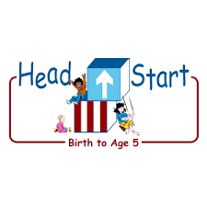PARENT ACTIVITY LETTER

CHILD’S NAME: ______________________

RATETHIS ACTIVITY FROM 1-5, CIRCLE YOUR RATING (5=HIGHEST RATING): 1 2 3 4 5
COMMENTS ABOUT THE ACTIVITY:
_______________________________________________________________________________________________________________________
**At this time while your child is learning at home, there’s no need to return this PAL to school, but you can keep it to go over with your child as a follow-up learning experience.
**Remember to have fun learning together!

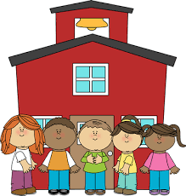
5/6/2020

REMOTE lEARNING ACTIVITIES
The PAL Letters are developed to support your child’s academic/social-emotional progress and are related to the program’s School Readiness goals.
FOCUS BOOK
Recommended Read Aloud: Chicka Chicka Boom Boom by Bill Martin Jr and John Archambault
***Please remember to read aloud to your child daily. We recommend reading a minimum of 3 hours per week with your child.
Why It’s Important:
Children can develop their understanding of rhyme by thinking of rhyming words. Giving your child riddles to figure out keeps them interested as they use thinking skills to solve the word riddle.
Primary Objectives for the activity
This activity will encourage objective 15a: Notices and discriminates rhyme.

At home, invite your child to: play a game called Rhyming Riddles. First, explain that rhyming words sound alike at the end. Offer a few examples such as, “cat and bat” and “sit and fit.” Invite your child to name any rhyming words. Next, explain that a riddle is a word puzzle that you need to figure out. Now, pose a riddle that prompts your child to supply a rhyming word. For example, “I’m thinking of something that you wear on your hands in the winter that rhymes with kittens. What am I thinking of?” If your child gives an incorrect answer, offer comments to help them figure it out, “Listen to the two words, do glove and kittens sound the same at the end?”
To extend this activity: help your child think of rhyming riddles they can ask other members of the family. Begin by asking your child for two rhyming words. Then, ask your child to describe one of the words. Help your child put their own riddle together. Play for as long as your child is interested!

