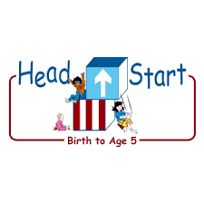PARENT ACTIVITY LETTER

CHILD’S NAME: ______________________

RATETHIS ACTIVITY FROM 1-5, CIRCLE YOUR RATING (5=HIGHEST RATING): 1 2 3 4 5
COMMENTS ABOUT THE ACTIVITY:
_______________________________________________________________________________________________________________________
**At this time while your child is learning at home, there’s no need to return this PAL to school, but you can keep it to go over with your child as a follow-up learning experience.
**Remember to have fun learning together!

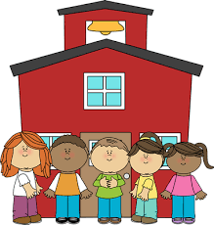
5/5/2020

REMOTE lEARNING ACTIVITIES
The PAL Letters are developed to support your child’s academic/social-emotional progress and are related to the program’s School Readiness goals.
FOCUS BOOK
Recommended Read Aloud: Our Tree Named Steve by Alan Zweibel
***Please remember to read aloud to your child daily. We recommend reading a minimum of 3 hours per week with your child.
Why It’s Important:
Children are naturally curious. They learn about the world around them through observation, inquiry, and interaction. Giving your child opportunities to ask questions about their interests promotes language and understanding of new concepts.
Primary Objectives for the activity
This activity will encourage objectives 9b. Speaks Clearly and 11d. Shows curiosity and motivation.

At home, invite your child to: ask you one special question. Encourage your child to think about the special question they want to ask you today. Give them time to put it into words. Listen to the question without interrupting your child. Offer prompts if your child is having difficulty thinking of a question, “If you would like to know what we are doing today, you could ask me, what are we doing today?” Make sure to give your child an answer to their special ‘Question of the Day!’
To extend this activity: you can write your child’s question on a piece of paper as they ask you. Then, write your answer and read to your child what you have written, pointing to the words as you read them.

