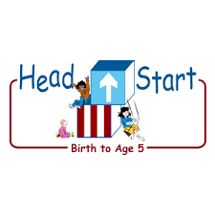PARENT ACTIVITY LETTER

CHILD’S NAME: ______________________

RATETHIS ACTIVITY FROM 1-5, CIRCLE YOUR RATING (5=HIGHEST RATING): 1 2 3 4 5
COMMENTS ABOUT THE ACTIVITY:
_______________________________________________________________________________________________________________________
**At this time while your child is learning at home, there’s no need to return this PAL to school, but you can keep it to go over with your child as a follow-up learning experience.
**Remember to have fun learning together!

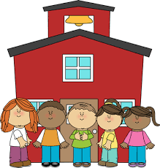
5/4/2020

REMOTE lEARNING ACTIVITIES
The PAL Letters are developed to support your child’s academic/social-emotional progress and are related to the program’s School Readiness goals.
FOCUS BOOK
Recommended Read Aloud: The Grouchy Ladybug by Eric Carle
***Please remember to read aloud to your child daily. We recommend reading a minimum of 3 hours per week with your child.
Why It’s Important:
Providing fun ways for your child to talk about feelings when not in the moment of experiencing an intense emotion is a great way to help them recognize, name, and learn appropriate strategies for managing these feelings in the future.
Primary Objectives for the activity
This activity will encourage objective 1a. Manages feelings.

At home, invite your child to: sing a song about feelings, “If You’re Happy and You Know It.” (If you’re happy and you know it, clap your hands. If you’re happy and you know it clap your hands. If you’re happy and you know it and you’re face will surely show it. If you’re happy and you know it clap your hands…angry: stomp your feet…excited: shout hurray.) Introduce the feelings that will be in the song (happy, angry, excited). Invite your child to make faces that express those feelings and you can model faces to demonstrate those feelings. You can say, “This song is about when we are angry. Can you make an angry face? This is my angry face.”
To extend this activity: help your child think of new feelings, actions, and facial expressions to add to the song. For example, “If you’re worried and you know it, give yourself a hug.” Ask your child, “What would your worried face look like?”

