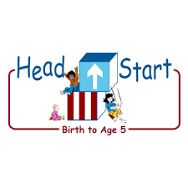PARENT ACTIVITY LETTER

CHILD’S NAME: ______________________

RATETHIS ACTIVITY FROM 1-5, CIRCLE YOUR RATING (5=HIGHEST RATING): 1 2 3 4 5
COMMENTS ABOUT THE ACTIVITY:
_______________________________________________________________________________________________________________________
**At this time while your child is learning at home, there’s no need to return this PAL to school, but you can keep it to go over with your child as a follow-up learning experience.
**Remember to have fun learning together!

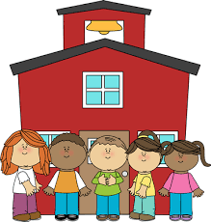

REMOTE lEARNING ACTIVITIES
The PAL Letters are developed to support your child’s academic/social-emotional progress and are related to the program’s School Readiness goals.
FOCUS BOOK
Recommended Read Aloud: Button, Button, Who’s Got the Button? By Trish Holland.
***Please remember to read aloud to your child daily. We recommend reading a minimum of 3 hours per week with your child.
Why It’s Important:
Many children love to move their bodies through space in different ways. This activity encourages your child to be active while helping him master spatial concepts.
Primary Objectives for the activity
This activity will encourage obj. 4: Demonstrates traveling skills and obj. 21a: understands spatial relationships

At home, invite your child to use chalk outdoors or masking tape indoors to create a path of “Stepping-Stones” around the space. Invite your child to jump from stone to stone. As he or she moves, help him or her notice where he or she is in relation to his or her surroundings. For example, “I see that you are near the door, but you are far from the window.” Encourage him or her to describe where he or she is in relation to you or any other people participating. For example, “Whom do you think is closest to you?” “Who is behind you?”

To extend this activity: Switch places and continue the activity by moving along the stones and asking your child to describe your position as you move. For example, “Where am I now?” “What am I next to?” Vary the game by placing the stones in a different area of the room or outdoor space. Continue the activity as long as your child is interested. Have Fun!

