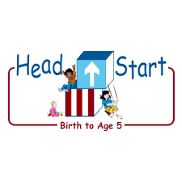PARENT ACTIVITY LETTER

CHILD’S NAME: ______________________

RATE THIS ACTIVITY FROM 1-5, CIRCLE YOUR RATING (5=HIGHEST RATING): 1 2 3 4 5
COMMENTS ABOUT THE ACTIVITY:
_______________________________________________________________________________________________________________________
**At this time while your child is learning at home, there’s no need to return this PAL to school, but you can keep it to go over with your child as a follow-up learning experience.
**Remember to have fun learning together!

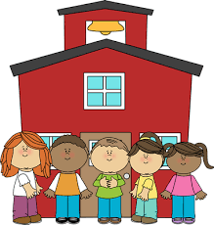

REMOTE lEARNING ACTIVITIES
The PAL Letters are developed to support your child’s academic/social-emotional progress and are related to the program’s School Readiness goals.
FOCUS BOOK
Recommended Read Aloud: Uncle Nacho‘s Hat by Harriet Rohmer.
***Please remember to read aloud to your child daily. We recommend reading a minimum of 3 hours per week with your child.
Why It’s Important:
Young children are continually learning about the world around them. Your child’s ability to communicate via spoken language becomes increasingly important as he or she attempts to gain new information by asking questions.
Primary Objectives for the activity
This activity will encourage 10a: Engages in conversations

At home, invite your child to interview a friend or family member, in order to learn more about that person. Ask him or her to choose whom he or she would like to interview and help him or her get permission to do so if needed. Encourage your child to think about two questions to ask. Help him or her think of appropriate questions, such as “How old are you?” “Do you have any pets?” “Do you have a brother or a sister?” “What color do you like best?” Give your child the opportunity to practice the interview with you if he or she chooses.

To extend this activity: After the interview, talk about what your child learned about the person he or she spoke with. Remind him or her that asking questions is a good way to learn new information.

