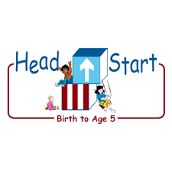PARENT ACTIVITY LETTER

CHILD’S NAME: ______________________

RATETHIS ACTIVITY FROM 1-5, CIRCLE YOUR RATING (5=HIGHEST RATING): 1 2 3 4 5
COMMENTS ABOUT THE ACTIVITY:
_______________________________________________________________________________________________________________________
**At this time while your child is learning at home, there’s no need to return this PAL to school, but you can keep it to go over with your child as a follow-up learning experience.
**Remember to have fun learning together!

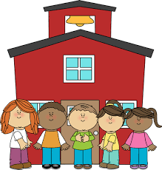

REMOTE lEARNING ACTIVITIES
The PAL Letters are developed to support your child’s academic/social-emotional progress and are related to the program’s School Readiness goals.
FOCUS BOOK
Recommended Read Aloud: Wash and Dry by Trish Holland.
***Please remember to read aloud to your child daily. We recommend reading a minimum of 3 hours per week with your child.
Why It’s Important:
Your child will learn more about everyday objects by including them in experiments that challenge his/her thinking skills. Conducting a basic test to determine one attribute of an object will allow your child to practice predicting outcomes, comparing and classifying objects.
Primary Objectives for the activity
This activity will encourage 11d: Shows curiosity and motivation.

At home, fill the dishpan halfway with water. Place the objects on a small table next to the water. Invite your child to play at the table. Help him or her put on a smock and explain that you want to find out which objects sink, and which objects float in the water. Talk about things he or she has seen sink or float: “You have a toy boat that floats in the bath.” “What else do you play with in the tub that sinks to the bottom when you put it in your bath?” Invite your child to pick up an object and drop it in the water. Ask him or her to determine whether it sinks or floats.

To extend this activity: Encourage your child to choose an object and make a prediction before dropping it in the water: “I see that the small pinecone is floating in the water.” “What do you think the leaf will do?” When your child is finished, ask him or her to collect and sort the objects on the table.

