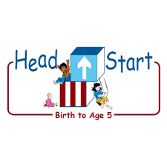PARENT ACTIVITY LETTER

CHILD’S NAME: ______________________

RATETHIS ACTIVITY FROM 1-5, CIRCLE YOUR RATING (5=HIGHEST RATING): 1 2 3 4 5
COMMENTS ABOUT THE ACTIVITY:
_______________________________________________________________________________________________________________________
**At this time while your child is learning at home, there’s no need to return this PAL to school, but you can keep it to go over with your child as a follow-up learning experience.
**Remember to have fun learning together!

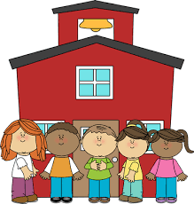

REMOTE lEARNING ACTIVITIES
The PAL Letters are developed to support your child’s academic/social-emotional progress and are related to the program’s School Readiness goals.
FOCUS BOOK
Recommended Read Aloud: Little Red Riding Hood by Bonnie Dobkin
***Please remember to read aloud to your child daily. We recommend reading a minimum of 3 hours per week with your child.
Why It’s Important:
Observe time when your child uses acceptable strategies for managing his/her own feelings. Also look for times when your child may be in a new situation and may need your assistance to manage his/her feelings. Guiding the behavior teaches how to express the self and interact with others.
Primary Objectives for the activity
This activity will encourage 1a: Manages feelings.

At home, observe how your child manages his or her feelings. When your child uses acceptable strategies, acknowledge the behavior and encourage it by explaining the desired outcome. For example, another child takes a truck from your child, your child says “No, that’s my truck!” and then looks at you. You might respond by saying. “You told her that was your truck and now she knows you had it first and that you want it back.

To extend this activity: In new situations where your child may not already have proven strategies to try, give him/her words to use. For example, your child tries many times unsuccessfully to put on her/his own shoes. He/she begins to kick her/his legs in frustration. You approach him/her and say, “I know it is frustrating when you can’t get your shoes on.” “You always ask me for help when you get stuck”. “You can say, please help me.”

