CHILD’S NAME: ______________________

RATETHIS ACTIVITY FROM 1-5, CIRCLE YOUR RATING (5=HIGHEST RATING): 1 2 3 4 5
COMMENTS ABOUT THE ACTIVITY:
_______________________________________________________________________________________________________________________
**At this time while your child is learning at home, there’s no need to return this PAL to school, but you can keep it to go over with your child as a follow-up learning experience.
**Remember to have fun learning together!

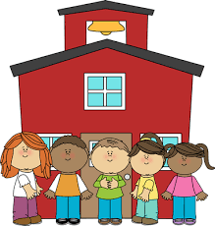

REMOTE lEARNING ACTIVITIES
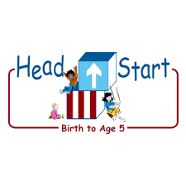
PARENT ACTIVITY LETTER
The PAL Letters are developed to support your child’s academic/social-emotional progress and are related to the program’s School Readiness goals.
Recommended Read Aloud: Sort it Out! By Barbara Mariconda
Why It’s Important:
Classification is a skill of sorting or grouping items by similar characteristics, such as colors, shapes or sizes. Cleanup time can be fun, and it will teach your child organizational skills as he/she sorts his/her toys and talks about the resulting groups.
***Please remember to read aloud to your child daily. We recommend reading a minimum of 3 hours per week with your child.
Primary Objectives for the activity
This activity will encourage 13. Uses classification skills

At home, invite your child to: ask your child to help you organize their toys. Place a large collection of toys on the table (or any surface to spread them out) and ask your child to make some suggestions in how to organize the toys so he/she can easily find what they need. Take note of your child’s suggestions and then ask him/her to sort the toys into various containers. A sample response: I like your idea for sorting the dollhouse parts and the parts to the Legos. Can you show me how you will sort then into these containers? Talk about how to make the toys into various containers Suggest making word or picture labels for the containers. Encourage you’re your child to help you label each container by drawing a picture to attach to the front. Write the name of the toy next to your child’s picture. Sample response: You drew a puzzle piece, so I will write ‘Puzzles’ next to your picture.
To extend this activity: Look for other opportunities for your child to sort collections around the house as a way to help you organize.

