**CHILD’S NAME: ______________________**

**RATETHIS ACTIVITY FROM 1-5, CIRCLE YOUR RATING (5=HIGHEST RATING): 1 2 3 4 5**

**COMMENTS ABOUT THE ACTIVITY:**

**_______________________________________________________________________________________________________________________**

**\*\*At this time while your child is learning at home, there’s no need to return this PAL to school, but you can keep it to go over with your child as a follow-up learning experience.**

**\*\*Remember to have fun learning together!**

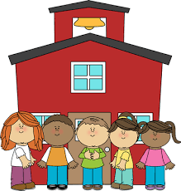

**REMOTE lEARNING ACTIVITIES**

**PARENT ACTIVITY LETTER**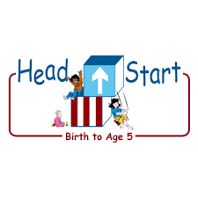

*The PAL Letters are developed to support your child’s academic/social-emotional progress and are related to the program’s School Readiness goals.*

**Recommended Read Aloud:** *Little Oink By Amy Krouse*

**Why It’s Important:**

When you provide examples and model expected behavior, you help your child understand how and when to care for household materials. Although your child may be physically capable of completing specific tasks at home, he/she continues to learn by example. This activity will reinforce your home routines and expectations.

***\*\*\*Please remember to read aloud to your child daily. We recommend reading a minimum of 3 hours per week with your child.***

**Primary Objectives for the activity**

1b. Follows limits and expectations, 4. Demonstrates traveling skills

**At home, invite your child to:** Before you invite your child, be sure there are several things out in the room that needs to be put away. Include variety of objects to be put in different locations around the room. Invite your child to play follow the leader. Ask your child to follow you around the room and do what you do. Walk or march in a silly way to make cleaning up more enjoyable. Walk slowly around the room picking up a toy and putting it away, then wait for your child to repeat your movements. Explain each task as you complete it. Sample response, *Now I am hanging a coat on the hook. Now you are hanging the coat on the hook.* When the room is clean, remember to thank your child for their help with the task. Recall with your child all the areas that were messy and list together the items put away. Point out how nice the room looks when it is clean and how easy it will be to find toys and materials later when he/she wants to use them.

**To extend this activity:** You can extend this activity by giving your child an opportunity to be the leader. Mimic his/her motions as he/she moves around the room putting things away.