Parent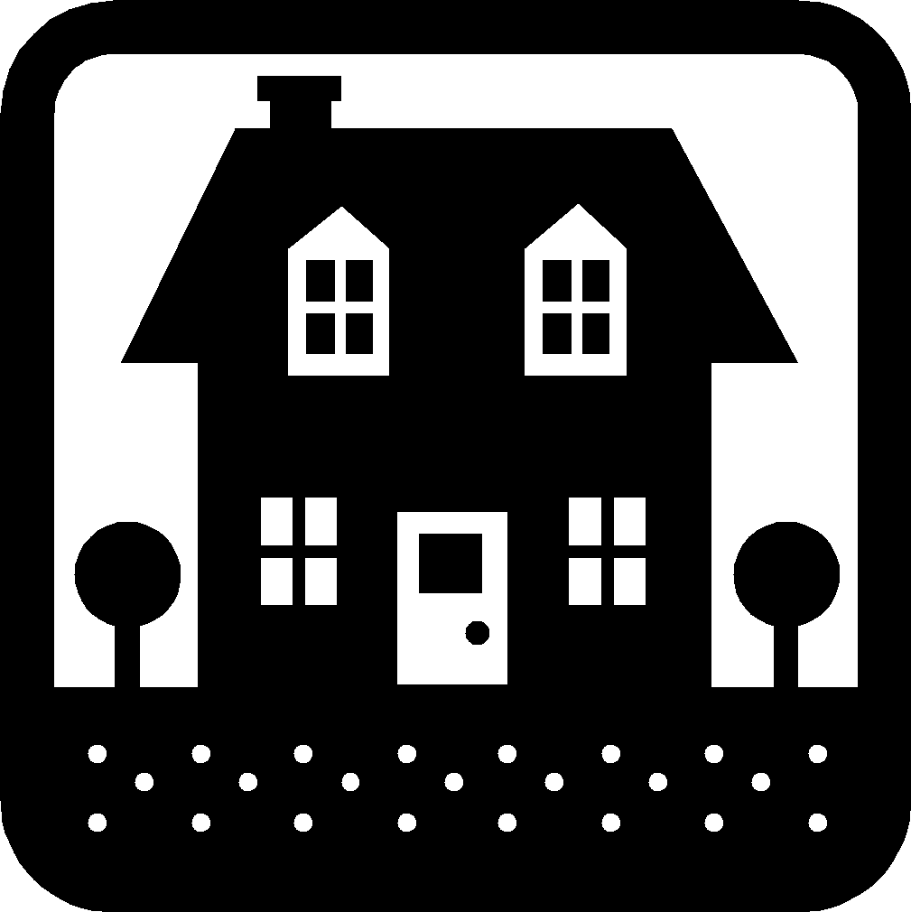Activity
Letter
Today, we recommend the book, “Going on a Bear Hunt"” by Michael Rosen. In class, we focused on mastering our traveling skills. We used a variety of traveling skills to move and transition throughout our classroom and while we were playing on the playground. For instance, children moved from one activity to the another by walking slowly, quickly, sideways, and/or backwards while following the teacher's directions. This activity can help promote physical development using Objective 4. Demonstrating Traveling Skills.
At Home, you can continue working on traveling your skills, while maintaining your household routines. There is always something to put away around the house, invite your child to play "Follow the Leader". Have your child follow you around the house while doing exactly what you do. Together, walk or march in a silly way to make cleaning up more enjoyable. Walk slowly around the room, picking up the toys and putting them away while explaining your movements. Then wait for your child to repeat your actions. For example, you’ll say, " I am putting the toy on the shelf." Then together say, "We are putting the toys on the shelf." Take turns being the leader with your child. To extend this activity, recall with your child all the areas that were messy and create a list of all the items your child helped put away.
Please remember to read aloud to your child daily. We recommend reading a minimum of 3 hours a week with your child.
The PAL letters are developed to support your child’s academic/social emotional progress and related to the programs School Readiness goals.
Friday: Return by
Child’s Name: ___________________________ Parent Name: _____________________________
Rate this activity from 1-5, circle your rating (5= highest rating): 12 3 4 5
Comments about the activity: ________________________________________________________________
I agree that completing the at home activity and reading aloud to my child is equivalent to four hours volunteer time for the week.

Parent’s Signature: ____________________________ Room:

