**CHILD’S NAME: ______________________**

**RATETHIS ACTIVITY FROM 1-5, CIRCLE YOUR RATING (5=HIGHEST RATING): 1 2 3 4 5**

**COMMENTS ABOUT THE ACTIVITY:**

**_______________________________________________________________________________________________________________________**

**\*\*At this time while your child is learning at home, there’s no need to return this PAL to school, but you can keep it to go over with your child as a follow-up learning experience.**

**\*\*Remember to have fun learning together!**

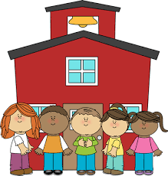

**REMOTE lEARNING ACTIVITIES**

**PARENT ACTIVITY LETTER**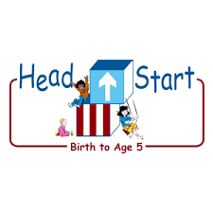

*The PAL Letters are developed to support your child’s academic/social-emotional progress and are related to the program’s School Readiness goals.*

**Recommended Read Aloud:** *Feast for Ten By Cathryn Falwell*

**Why It’s Important:**

Children enjoy making sounds and rhythms with everyday objects. This activity helps your child recognize and repeat patterns as he/she learns

***\*\*\*Please remember to read aloud to your child daily. We recommend reading a minimum of 3 hours per week with your child.***

**Primary Objectives for the activity**

23. Demonstrate Knowledge of Patterns

**At home, invite your child to:** help you gather some spoons, some blocks or whatever you may have gathered to use as an instrument to make sound. Invite your child to listen to the sounds you make with the spoons (or what you gathered to create a sound). Clap two spoons together in a simple rhythm, such as one-two, one-two. Give your child their own spoons to use, and encourage him/her to repeat the rhythm. When your child can repeat a simple rhythm, extend the pattern, such as one-two-three, one-two-three. Ask questions that prompt your child to think about and discuss the sounds he/she hears. Sample response, *Listen to the spoons. Can you make your spoons sound like that?* Remember to praise your child for trying. Observe your child as he/she repeats the rhythm. Note if your child is keeping a steady beat or randomly clapping their spoons together. Speed up or slow down the rhythm as needed.

**To extend this activity:** Continue the game by encouraging your child to create a pattern for you to repeat. Sample response, *It’s your turn to make a rhythm. I’ll clap the pattern you make.* Get creative and use other materials around the house to make rhythm patterns such as a spoon to bang on the back of a pot or box and or just by clapping your hands.