CHILD’S NAME: ______________________

RATETHIS ACTIVITY FROM 1-5, CIRCLE YOUR RATING (5=HIGHEST RATING): 1 2 3 4 5
COMMENTS ABOUT THE ACTIVITY:
_______________________________________________________________________________________________________________________
**At this time while your child is learning at home, there’s no need to return this PAL to school, but you can keep it to go over with your child as a follow-up learning experience.
**Remember to have fun learning together!

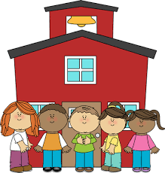

REMOTE lEARNING ACTIVITIES
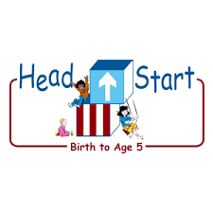
PARENT ACTIVITY LETTER
The PAL Letters are developed to support your child’s academic/social-emotional progress and are related to the program’s School Readiness goals.
Recommended Read Aloud: Alphabet Everywhere By Elliott Kaufman
Why It’s Important:
Children learn about print in meaningful context. Encouraging your child to use illustrations to create and recall text will help him/her understand that print carries meaning.
***Please remember to read aloud to your child daily. We recommend reading a minimum of 3 hours per week with your child.
Primary Objectives for the activity
This activity will encourage 18. Speaks Clearly and 18a. Interacts during reading experiences, book conversations, and text reflections

At home, invite your child to: help gather some markers, pencils or other writing tools; white paper or whatever solid color paper you can find; pictures of your child, with family, friends, trips or special events; glue, stapler and or tape to create your book. Attach one photo to each piece of paper. Staple the pages together along the left side to create a book. Invite your child to look at the pictures in the book. Explain that he/she may talk about what is happening in each picture, and you will write your child’s words on the page. Sample response, We’ll make a book about what you like to do using these pictures. Then, we can read the book later with the words we’ve written down. Encourage your child to share ideas about the pictures. Write down his/her words as he/she talks about each picture. When the book is finished, read it with your child. Ask questions about the book as you read together.
To extend this activity: Explain to your child that they are the Author of the book you just created and that the pictures are the illustrations in your book. Encourage your child to use the pictures to help him/her read the book with a family member.

