ParentActivity

Letter

**Today, we recommend** the focus book, ***“Fledging”*** by Robert J. Blake. In class, wetalk about sequencing, what comes first, second, and third.

**At home,** you and your child can continue talking what how important it is to go in order, in sequence order. For example, when it’s time to brush teeth, talk about how important it is to follow the order of brushing one’s teeth. 1stwe wet the toothbrush, 2ndwe put tooth paste on the toothbrush, and3rd we begin to brush our teeth up and down and back-and-forth. It’s a great way to learn about sequencing and learn about the importance of healthy teeth. To extend the activity your child can count the steps in brushing the teeth.

***\*\*\*Please remember to read aloud to your child daily. We recommend reading a minimum of 3 hours a week with your child. C:\Users\BCCAP- Head Start\AppData\Local\Microsoft\Windows\Temporary Internet Files\Content.IE5\VAOL3GO4\MC900437791[1].wmf***

**The PAL letters are developed to support your child’s academic/social emotional progress and related to the programs School Readiness goals.**

Friday**: __________________**Return by Thursday: ___________**________**

Child’s Name: _______________________________________________________________

Parent Name: _______________________________________________________________

Rate this activity from 1-5, circle your rating (5= highest rating): **1 2 3 4 5**

Comments about the activity: ________________________________________________________________

I agree that completing the at home activity and reading aloud to my child is equivalent to four hours volunteer time for the week.

**Parent’s Signature:** ____________________________ Room:**___________________**

[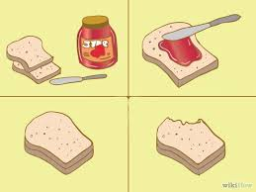](http://www.google.com/imgres?imgurl=http://pad1.whstatic.com/images/thumb/c/c5/Teach-Preschool-Children-Sequencing-Step-3.jpg/670px-Teach-Preschool-Children-Sequencing-Step-3.jpg&imgrefurl=http://www.wikihow.com/Teach-Sequencing-to-Preschool-Children&h=503&w=670&tbnid=y9kpW1XVTSj7fM:&docid=gfe3s2ojNNVpsM&ei=Xws9VtC2Horq-AG46bmYDw&tbm=isch&ved=0CCYQMygJMAlqFQoTCJDip7bP_MgCFQo1PgoduHQO8w)

[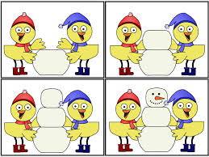](http://www.google.com/imgres?imgurl=http://2.bp.blogspot.com/-P9pmaGrH4lU/TwXcGrQUjII/AAAAAAAAAJI/DNDMMMJcnVM/s1600/winterbirdsequence1.gif&imgrefurl=http://a-childs-place.blogspot.com/2012_01_01_archive.html&h=720&w=960&tbnid=-dUeUdN4ueCMHM:&docid=LzoV6fuq5WYlHM&ei=Jgo9VtmTHoPZ-QGL77OABw&tbm=isch&ved=0CEAQMygZMBlqFQoTCNm-h6HO_MgCFYNsPgodi_cMcA)